**1.** the following models were all trained on the same data, select the model with the lowest value for alpha:

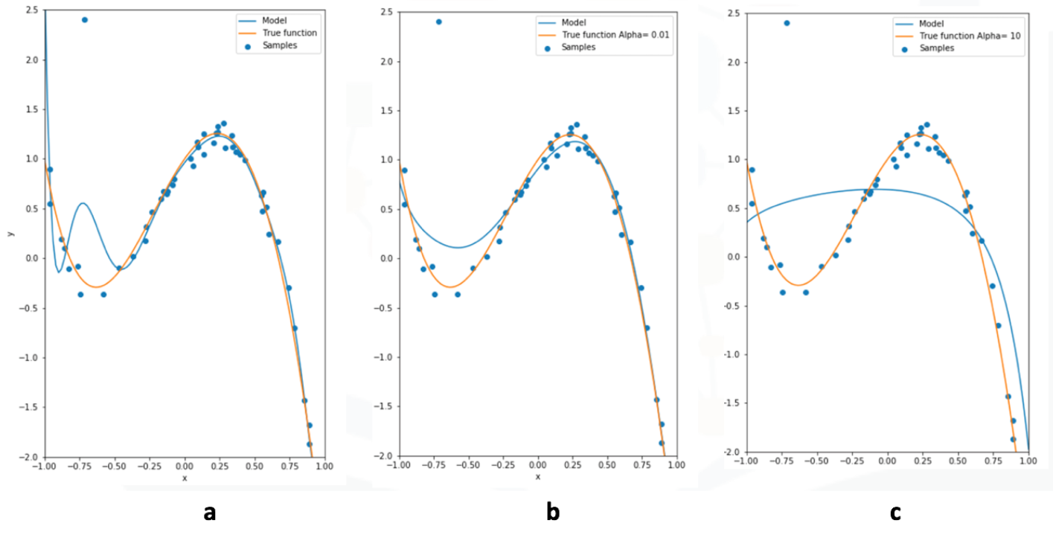

* a
* b
* c